Superstore Revenue Optimization Strategy
Executive Summary Report

Analysis Period: 2022-2025
Report Date: January 7, 2026

Executive Summary
Superstore can optimize revenue through a data-driven, region-specific discount strategy that protects margins on 623 high-value star products while liquidating 986 underperforming zombie SKUs. This analysis identifies which products to protect, which to discount, and when to deploy promotions based on regional seasonality patterns across four priority states (NY, CA, TX, FL).

Business Problem
Despite revenue growth, Superstore is suffering from sales inefficiencies due to a reactive, "one-size-fits-all" strategy. Without visibility into product-level performance, regional managers are applying blanket discounts that may be unnecessary for high-demand items or ill-timed for slow-moving inventory.

Business Question
How can we optimize revenue through targeted discounts by aligning product-level strategies with regional sales performance and seasonal demand patterns?

To answer the business question, the analysis is structured around three core decision dimensions:
- Where: Which regions offer the highest concentration of sales and should be prioritized?
- Which: What product strategies should be employed at a granular level?
- When: How does seasonality affect product demand, and when should discounts be deployed?

Dataset & Methodology
The analysis leverages the Global Superstore dataset, which provides detailed transaction-level information on sales volume, order frequency, and regional performance. We developed a 5-quadrant product classification system combined with seasonality mapping to create region-specific, data-driven discount and inventory strategies. The five product strategies are: Star (Protect), Luxury (Target), Traffic Builder (Bundle), Dead Zombie (Liquidate), and New/Niche (Watch List) — with the New/Niche category distinguishing recent products (less than 180 days on shelf) from true zombies.

Key Findings

National Performance (2022-2025)
- Total Revenue: $2.26M across 4 years
- Year-over-Year Growth: Consistent growth with strong Q4 performance
- Regional Leaders: West ($710K) > East ($670K) > Central ($493K) > South ($389K)
- Peak Seasons: Q4 dominates (38.5% of annual revenue), driven by November-December

Seasonality Insights
- High Demand Months:
- September (back-to-school): 59% above average
- November-December (holidays): 71-86% above average
- Low Demand Months:
- January-February (post-holiday): 15% below average
- June-July (summer slowdown): 8% below average

Strategic Framework: Product-Class Discount Strategy
This framework should be applied across all regions, with specific timing adjusted based on regional seasonality patterns (see individual state seasonality index visualizations in appendix).

Star Products (High Value + High Volume)
- Valley Periods: No discounts—maintain premium positioning
- Normal Periods: No discounts—preserve margin power
- Peak Periods: Bundle with New/Niche products to drive exposure without price reduction

Luxury Products (High Value + Low Volume)
- Valley Periods: Exclusive access programs, premium services, VIP early access—no public discounts
- Normal Periods: Maintain full pricing with added-value services
- Peak Periods: Prioritize availability for high-value customers and B2B accounts

Traffic Builder Products (Low Value + High Volume)
- Valley Periods: Aggressive discounts to stimulate traffic when natural demand is low
- Normal Periods: Moderate bundling without standalone discounts
- Peak Periods: Remove discounts, implement bulk bundling strategies to increase basket size

New/Niche Products (Recent Introductions <180 Days)
- Valley Periods: Limited trial offers to encourage initial adoption
- Normal Periods: Standard pricing with visibility campaigns
- Peak Periods: Bundle with star products to leverage high traffic for exposure

Dead Zombie Products (Old + Underperforming)
- All Periods: Continuous clearance regardless of seasonality—liquidate to eliminate carrying costs
Note: Valley periods are defined as months with seasonality index <0.8, peak periods as >1.2, and normal periods as 0.8-1.2. Specific timing varies by region and product category—refer to state-level seasonality index heatmaps.

Regional Deep-Dive: State Performance

🔴 EAST REGION: New York State
Market Share: 45.8% of East region revenue ($306K annually)

Market Characteristics
Category Mix:
- Technology: 41.4% (tech-forward market)
- Furniture: 30.2%
- Office Supplies: 28.4%
Top Revenue Drivers:
- Technology products: $95K (30.6% of NY revenue)
- Furniture products: $78K (25.2% of NY revenue)

Product Portfolio Classification
Strategy | Product Count | Revenue Share
Star (Protect) | 154 products | 40%
Luxury (Target) | 253 products | 50%
Traffic Builder (Bundle) | 72 products | 2%
Dead Zombie (Liquidate) | 244 products | 6%
New/Niche (Watch List) | 81 products | 2%

Seasonality Index Heatmap
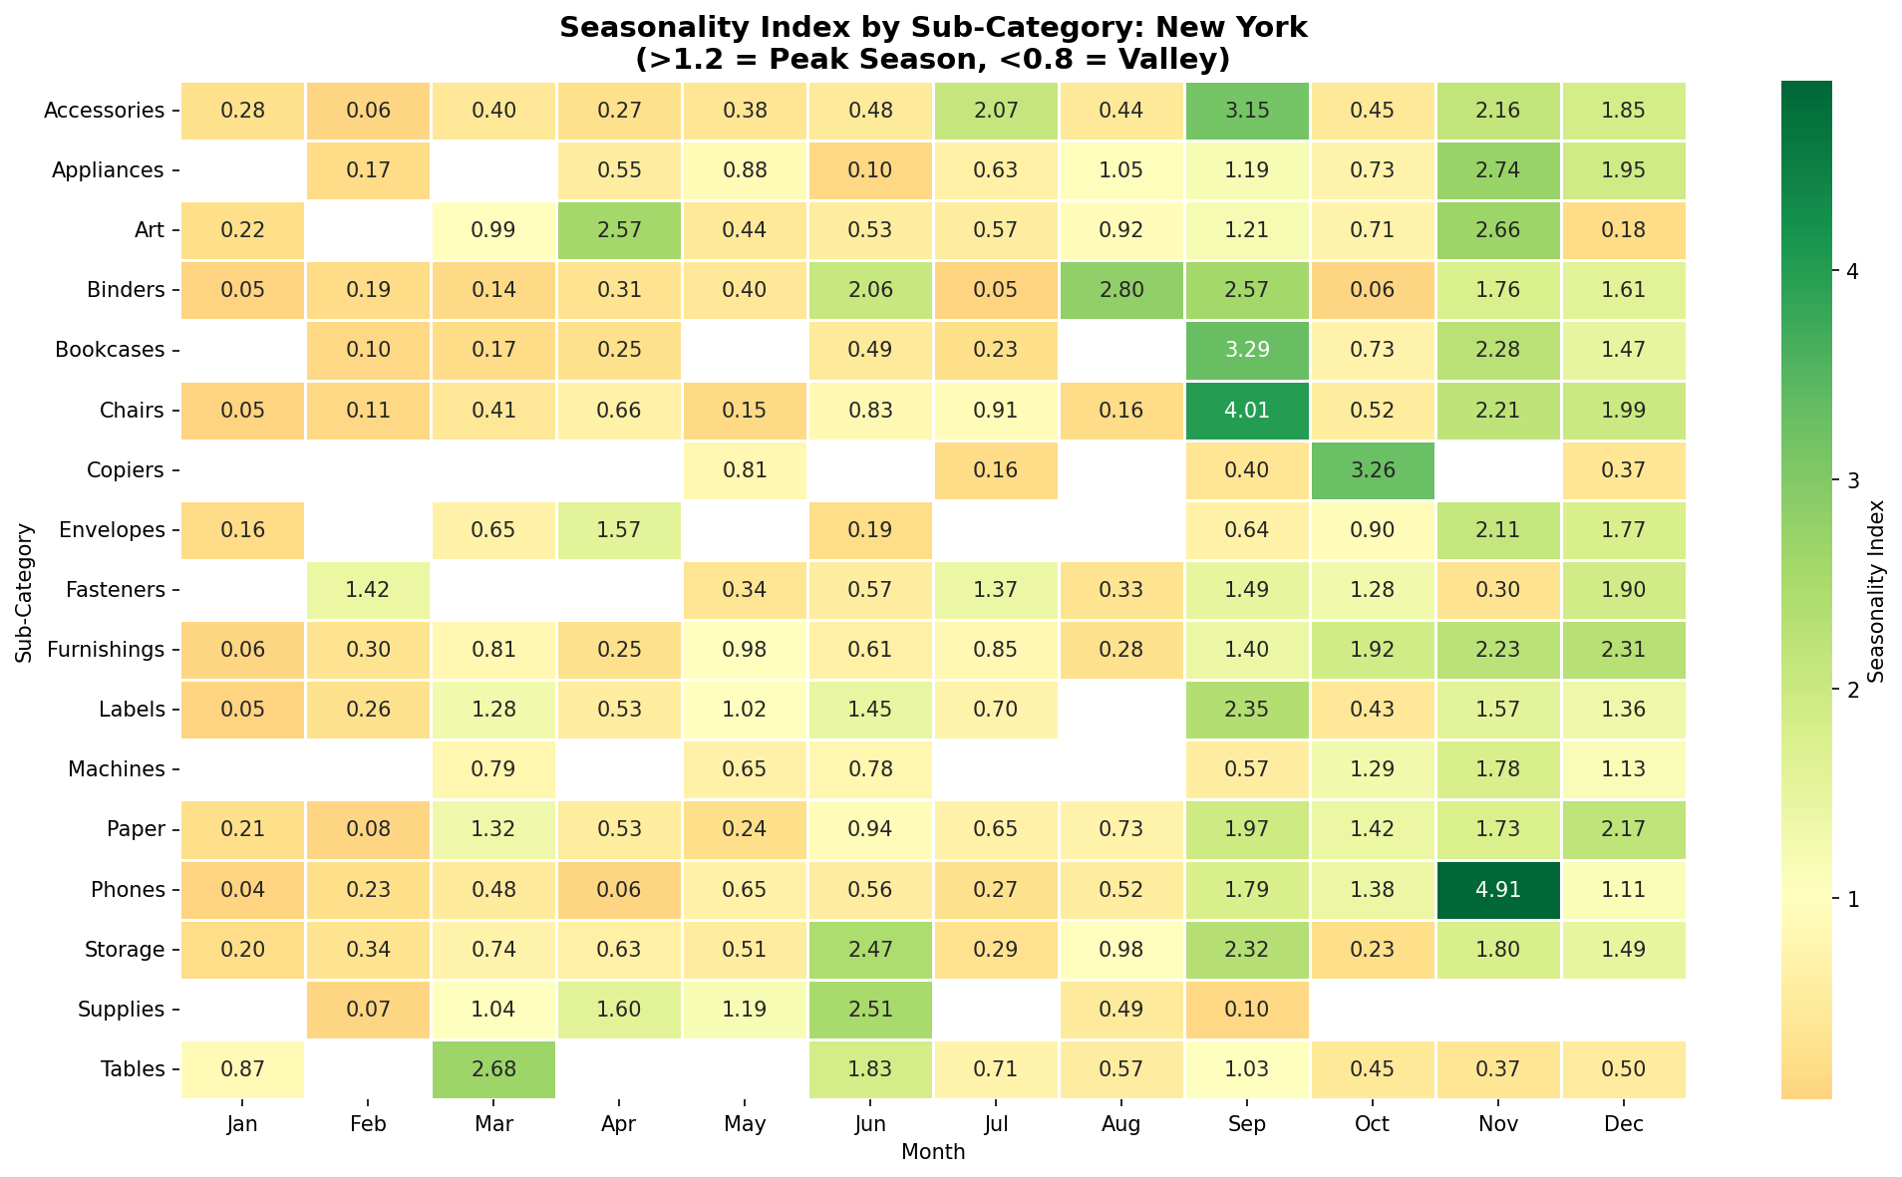

🟢 WEST REGION: California
Market Share: 62.8% of West region revenue ($446K annually)

Market Characteristics
Category Mix:
- Technology: 38.9%
- Office Supplies: 32.1%
- Furniture: 29.0%
Top Revenue Drivers:
- Technology & Office products: $72K (31.6% of CA revenue)
- Tech accessories: $58K (25.4% of CA revenue)
- Storage & Furniture: $52K (22.8% of CA revenue)

Product Portfolio Classification
Strategy | Product Count | Revenue Share
Star (Protect) | 308 products | 54%
Luxury (Target) | 289 products | 34%
Traffic Builder (Bundle) | 128 products | 3%
Dead Zombie (Liquidate) | 361 products | 7%
New/Niche (Watch List) | 97 products | 2%

Seasonality Index: Refer to CA seasonality heatmap visualization for product-specific peak/valley timing. Note irregular seasonality patterns (e.g., supplies peak in July). Apply strategic framework based on sub-category seasonal behavior.

Seasonality Index Heatmap
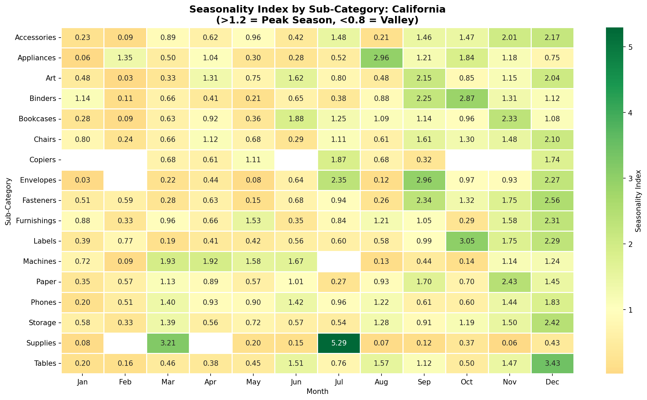

🔵 CENTRAL REGION: Texas
Market Share: 34.2% of Central region revenue ($169K annually)

Market Characteristics
Category Mix:
- Office Supplies: 35.7% (supply-driven market)
- Technology: 33.2%
- Furniture: 31.1%
Top Revenue Drivers:
- Office supplies: $41K (36.0% of TX revenue)
- Office equipment: $35K (30.7% of TX revenue)
- Furniture: $24K (21.1% of TX revenue)

Product Portfolio Classification
Strategy | Product Count | Revenue Share
Star (Protect) | 133 products | 40%
Luxury (Target) | 249 products | 47%
Traffic Builder (Bundle) | 40 products | 2%
Dead Zombie (Liquidate) | 265 products | 9%
New/Niche (Watch List) | 70 products | 2%

Seasonality Index: Refer to TX seasonality heatmap visualization for product-specific peak/valley timing. Strong back-to-school seasonality (Aug-Oct) dominates supply patterns. Apply strategic framework based on sub-category seasonal behavior.

Seasonality Index Heatmap
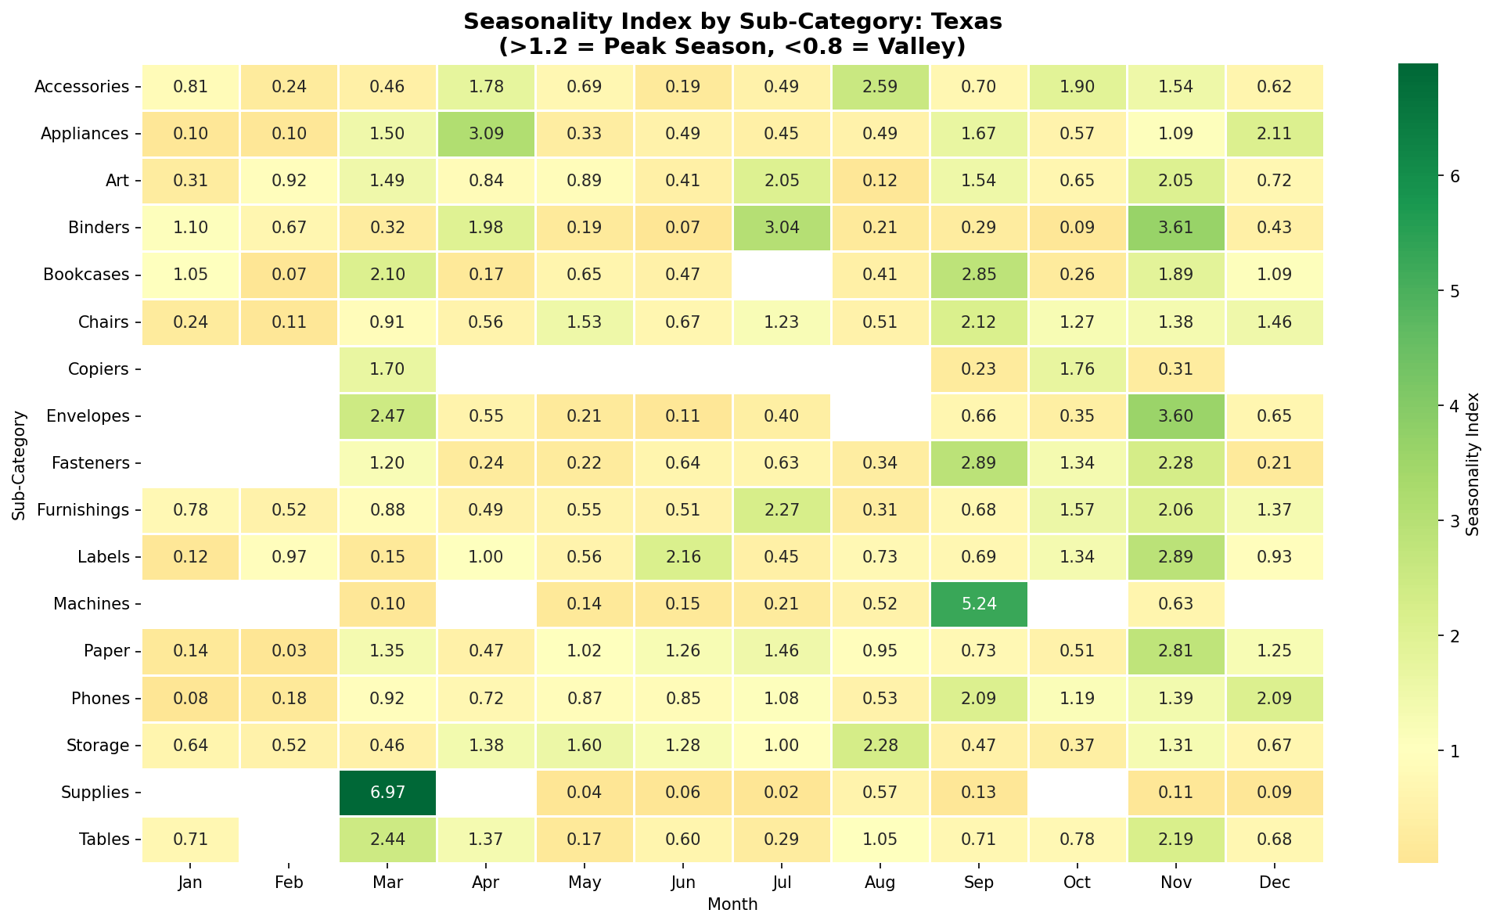

🟠 SOUTH REGION: Florida
Market Share: 22.7% of South region revenue ($88K annually)

Market Characteristics
Category Mix:
- Furniture: 36.4% (home office driven)
- Technology: 33.8%
- Office Supplies: 29.8%
Top Revenue Drivers:
- Furniture: $32K (36.4% of FL revenue)
- Technology: $28K (31.8% of FL revenue)
- Storage & Furnishings: $19K (21.6% of FL revenue)

Product Portfolio Classification
Strategy | Product Count | Revenue Share
Star (Protect) | 28 products | 9%
Luxury (Target) | 143 products | 82%
Traffic Builder (Bundle) | 11 products | 0%
Dead Zombie (Liquidate) | 116 products | 8%
New/Niche (Watch List) | 35 products | 2%

Seasonality Index: Refer to FL seasonality heatmap visualization for product-specific peak/valley timing. Strong year-end furniture demand (Sept-Dec) and home office focus. Apply strategic framework based on sub-category seasonal behavior.

Seasonality Index Heatmap
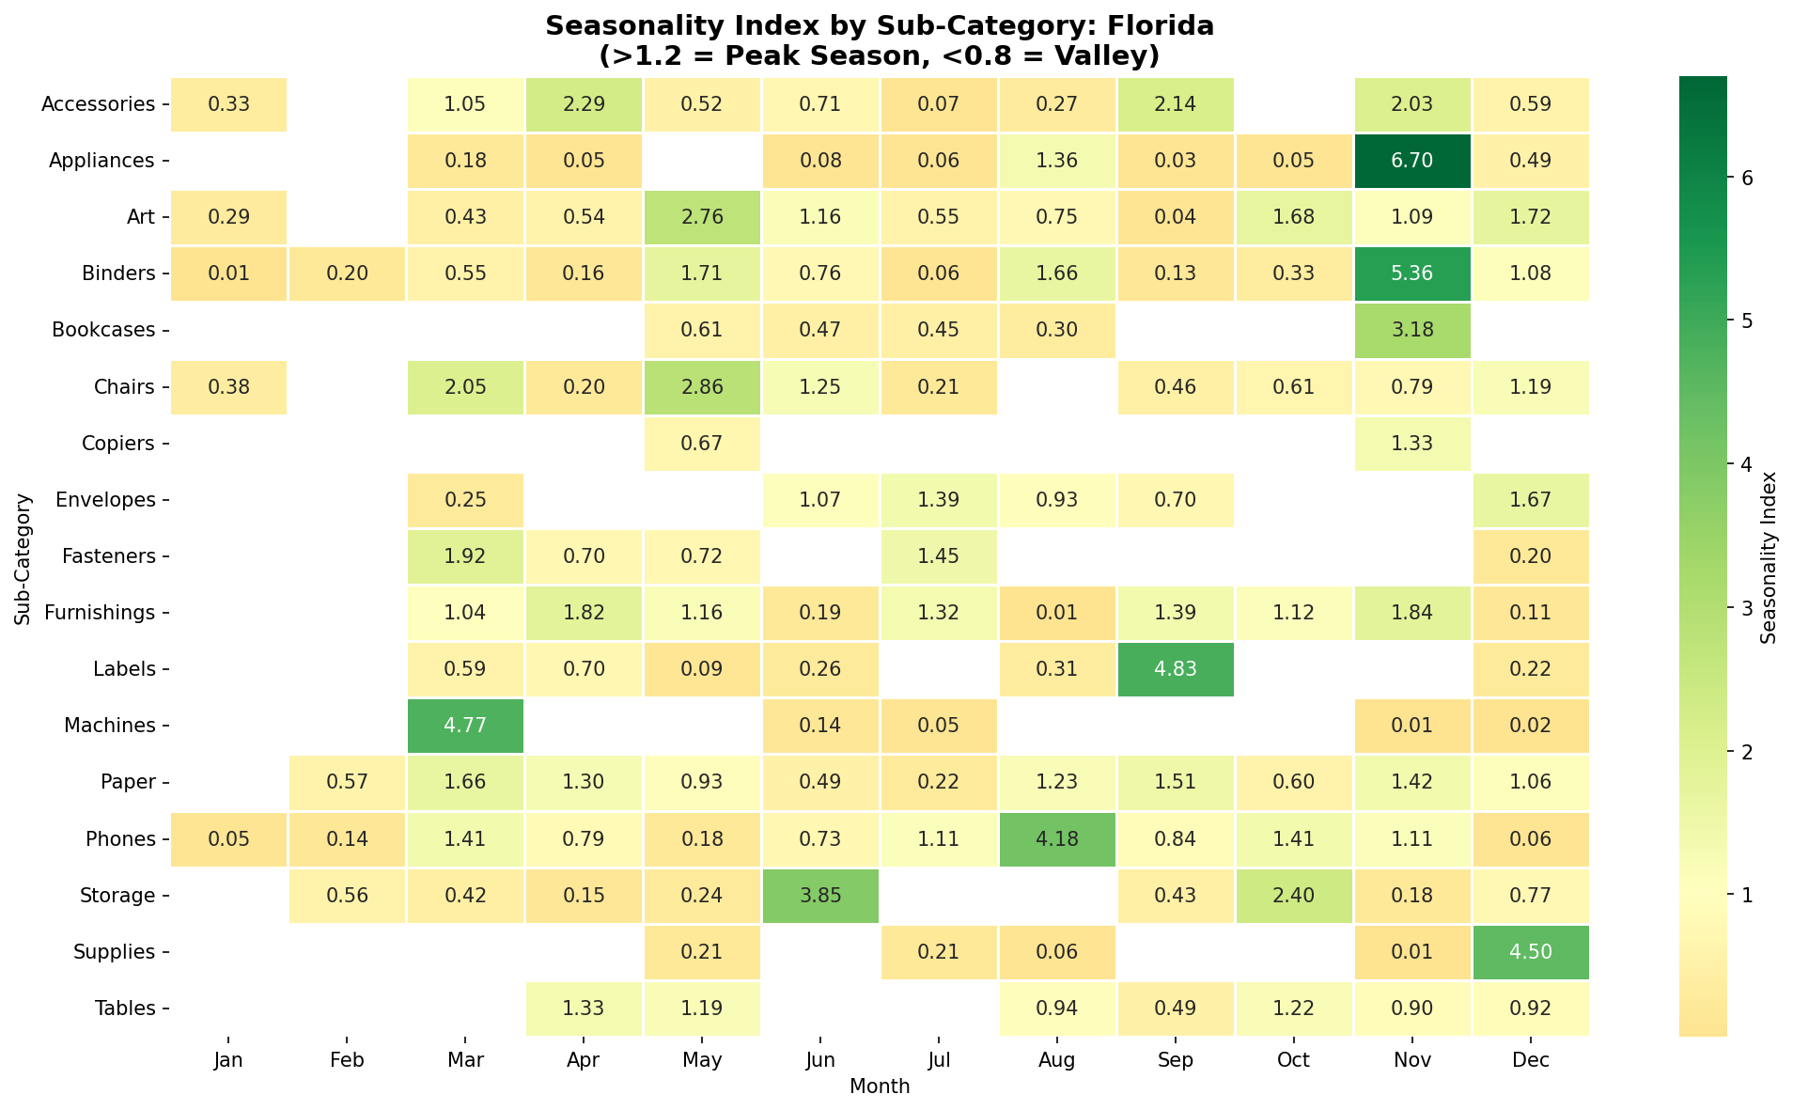

Implementation Roadmap

Phase 1: Foundation (Q1 2026)
Week 1-2:
- Tag all products in inventory system with strategy classification
- Remove star products from all automated discount campaigns
- Set up monthly seasonality alerts for category managers
Week 3-6:
- Launch "New Year Clearance" to liquidate 265 zombie SKUs nationwide
- Train sales team on new discount authorization matrix
- Implement inventory rebalancing (shift capital from zombies to stars)
Week 7-12:
- Analyze Q1 clearance performance
- Refine product classifications based on results
- Prepare Q2 valley campaign materials

Phase 2: Optimization (Q2-Q3 2026)
- Execute valley month campaigns (state-specific luxury promotions)
- Test traffic builder bundle configurations
- Monitor margin impact vs. volume tradeoffs
- Launch back-to-school harvesting strategy

Phase 3: Harvest & Evaluate (Q4 2026)
- Peak season margin protection (no star/luxury discounts)
- Final zombie liquidation push
- Calculate ROI vs. baseline (2025 performance)
- Refine classifications for 2027

Appendices

Appendix A: Product Classification Methodology

To move beyond simple revenue rankings, we adapted the BCG Growth-Share Matrix to segment the inventory based on performance relative to peer products.

The Classification Matrix (2x2) Products are plotted along two dimensions. Crucially, we utilized the Median as the threshold to prevent outliers from skewing the baseline.

Axis 1 (Vertical): Value. Defined as Total Sales relative to the Sub-Category Median Sales.

Axis 2 (Horizontal): Volume. Defined as Order Frequency relative to the Sub-Category Median Frequency.

Data Note: The dataset does not contain a "Quantity" column. Therefore, Order Frequency (Row ID count) was utilized as the proxy metric. This approach accurately captures consumer demand (how often a product is chosen) rather than unit volume, which is sufficient for demand segmentation.

Logic Rules:

Stars (High Value / High Volume): Performance > Median in both metrics.

Luxury (High Value / Low Volume): Sales > Median; Frequency < Median.

Traffic Builders (Low Value / High Volume): Sales < Median; Frequency > Median.

New/Niche (Low Value / Low Volume): Performance < Median in both metrics, but First Sale Date < 180 Days.

Zombies (Low Value / Low Volume): Performance < Median in both metrics, with No Sales in > 180 Days.

Appendix B: Seasonality Index Calculation
Seasonality was calculated to measure the magnitude of demand deviation from the mean, enabling the identification of "Peak" and "Valley" months.
Seasonality Index = (Monthly Sales) / (Average Monthly Sales for Sub-Category)
- Index >1.2: Peak season (harvest margins)
- Index 0.8-1.2: Normal demand
- Index <0.8: Valley season (strategic discounts)

Note: The Arithmetic Mean (Average) was used here, rather than the Median, to accurately capture the weight and capacity requirements of high-volume months.

Appendix C: State Selection Criteria
To maximize impact while minimizing risk, the rollout strategy focuses on "Powerhouse States" rather than a blanket national launch.
Selection Logic: For each of the four geographic regions (West, Central, South, East), states were selected based on revenue contribution:
- Primary Selection: The single state with the highest total revenue in the region.
- Secondary Selection: A second state is included only if its revenue is ≥ 80% of the Primary State's revenue.
Rationale: This filter isolates the markets that drive the majority of Global Superstore’s revenue (approx. 70%+ of regional totals), providing a statistically significant testbed for the new discount strategy without the operational cost of a 49-state rollout.

